Activity 1.2.3Center of Gravity

Introduction
If an object falls toward the Earth without air resistance,about what point will it tend to rotate? The center of gravity is where the mass of an object is concentrated or balanced.Therefore, an object tends to rotate about that point. Air resistance affects this rotation. In this activity you will calculate the location of the center of gravity for an aircraft which affects its stability.

Equipment
- Course binder

Procedure
- Determine if the aircraft below is loaded within the manufacturer’s recommendation. The pilot weights 165 lb and there is no co-pilot. The rear seat passengers weigh 251 and 296 lb. There is 98 lb of baggage and 58 lb of fuel onboard.

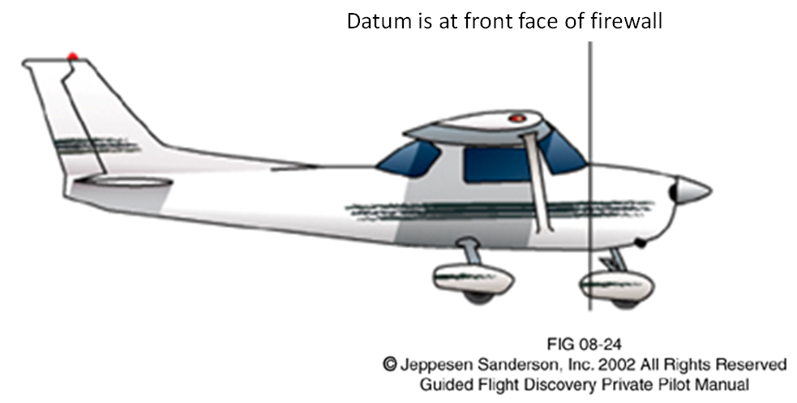

Item | Force  Weight (lb) | Distance  Arm (in.) | Moment (in.-lb)  M = Fd  M = weight ● arm
Empty Weight | 1460 | 37.4
Pilot |  | 37.0
Co-Pilot |  | 37.0
Fuel |  | 45.3
Rear seat passenger(s) |  | 72.8
Baggage |  | 94.9
Total

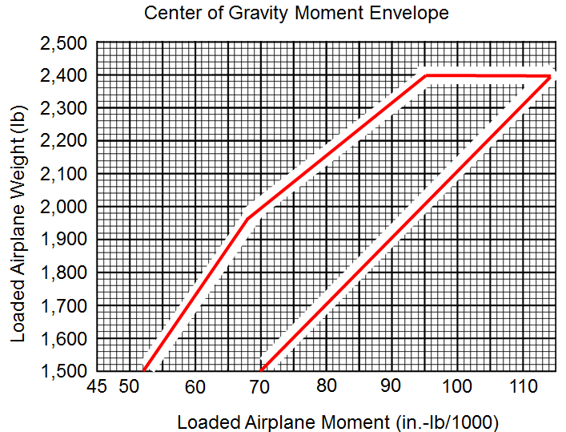

- If the aircraft is not loaded according to the manufacturer’s recommendation then suggest an alternative loading scenario so that the aircraft is safely loaded.
Item | Force  Weight (lb) | Distance  Arm (in.) | Moment (in.-lb)  M = Fd  M = weight ● arm
Empty Weight | 1460 | 37.4
Pilot |  | 37.0
Co-Pilot |  | 37.0
Fuel |  | 45.3
Rear seat passenger(s) |  | 72.8
Baggage |  | 94.9
Total

Conclusion
- What factors will affect the center of gravity of an aircraft?
- Explain why calculating the center of gravity of an aircraft is so important?

