Activity 1.2.4 Atmosphere

Introduction
Our atmosphere is a fragile blanket that surrounds the Earth. This mixture of gases containing mostly Nitrogen is crucial for us to survive and aircraft to fly. The atmosphere is cooler and lower pressure as one moves from the surface of the Earth to the frigid vacuum of space. The atmosphere being cooler, lower pressure and lower density has a significant impact on aircraft performance.

The rate has been measured and modeled as a formula. In this activity you will calculate the pressure and temperature at various altitudes.

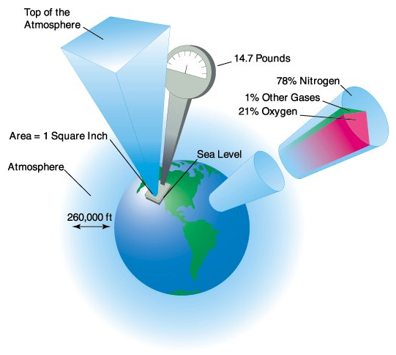

Equipment
- Computer with Microsoft® Excel®or software with similar functionality
- Atmosphere presentation

Procedure
- A F-35 is flying at 1,026 kph at 8,350 m. What is the air temperature assuming a standard surface temperature of 15 ^{O}C? Show all your calculations.
- A F-22 Raptor has just climbed through an altitude of 9,874 m at 1,567 kph when a disk ruptures in a sensitive piece of optical equipment. As the engineer analyzing the failure, determine the pressure differential across the sensor housing if the inside sensor pressure was 122 kPa.
- Develop a calculator to apply the temperature, pressure and density equations of the Earth’s standard atmospheric conditions to user inputs using Microsoft Excel. Show the formulas used and the correct units of each input and output. Verify that the answers calculated in the previous steps match the results of the calculator that you created. If there is a difference then resolve the error. Note that Excel may be substituted by another tool that your teacher approves.
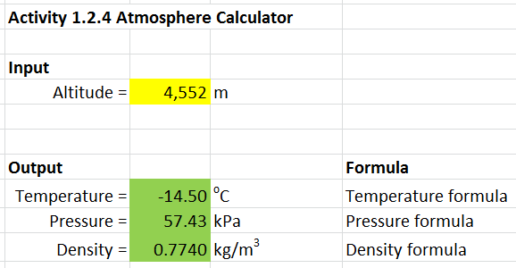
Excel Calculator Example

Conclusion
- Explain how the temperature lapse rate will affect aircraft design.
- Explain how the pressure lapse rate will affect aircraft design.

