Activity 1.3.1 Radio Navigation

Introduction
Have you ever experienced the panic of being lost? If you have never been lost, can you imagine how scary it might be? Now imagine being lost in an aircraft. To avoid this life-threatening experience, pilots use a variety of instruments and tools to navigate the open sky.Pilots often use a Very High Frequency Omnidirectional Range Station (VOR). A VOR is a device that aids a pilot’s navigation by providing bearing information based upon the transmission of two VHF signals, one that rotates and one that is stationary. In this activity you will use VOR system information to determine location.

Equipment
- Course binder
- Activity 1.3.1 Radio Navigation presentation

Procedure

- Plot the position of an aircraft displaying these VOR readings on the attached Chicago sectional map.

- What landmark is located under your aircraft? _________________________
- Your aircraft is located at 5,500 MSL above the location plotted in step 1. What will the DME device display if you are tuned to the Falls VOR-DME? Sketch and calculate this in your engineering notebook. Note that you researched this NavAid during your pre-flight planning. You know that the Falls VOR-DME is located at an elevation of 740 ft. Note that 1 nm = 1.15 statute miles = 6076 ft.
- Plot the position of an aircraft displaying these VOR readings on the Chicago sectional map on the following page. Use a pencil and ruler.

- Label the VOR instrument with the heading and flag indicator as if you were flying over Dundee (located below the center of the map). The VOR instrument is tuned to the Falls VOR-DME.

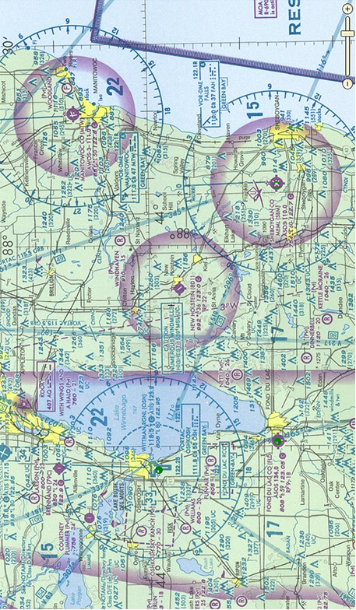
Conclusion
- What important factors must a navigator consider when selecting VOR sites?
- What important considerations doNon-Directional Beacons (NDB) present?
- How accurate would your DME reading be if your aircraft was flying 5,500 ft above Howard’s Grove and you tuned your DME to Falls VOR-DME?

