Activity 1.3.4 Air Traffic Control

Introduction
Air Traffic Controllers are a crucial part of a complex system intent on making flying safe. ATC decisions account for many variables, including aircraft performance, airport capacity, and weather.

In this activity you will become an air traffic controller and coordinate a group of aircraft to fly along a route safely.

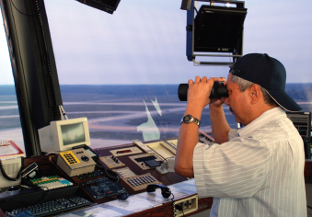

Equipment
- Computer with access to the NASA Traffic Control Simulator website
- Engineering notebook

Procedure
- Start the PC and open a web browser.
- Go to the NASA Traffic Control Simulator website: http://www.atcsim.nasa.gov/.
- Click on the Link to the Simulator to launch the software.
- Click on Select Problem, Three Airplanes, Problem 3-4. Leave the simulation paused.
- Display the routes by left clicking each of the flight numbers shown below the radar. Return and select Show Route. The radar return represents each of the three flights, and the labels indicate the call sign. For example AAL12 is American Airlines # 12.
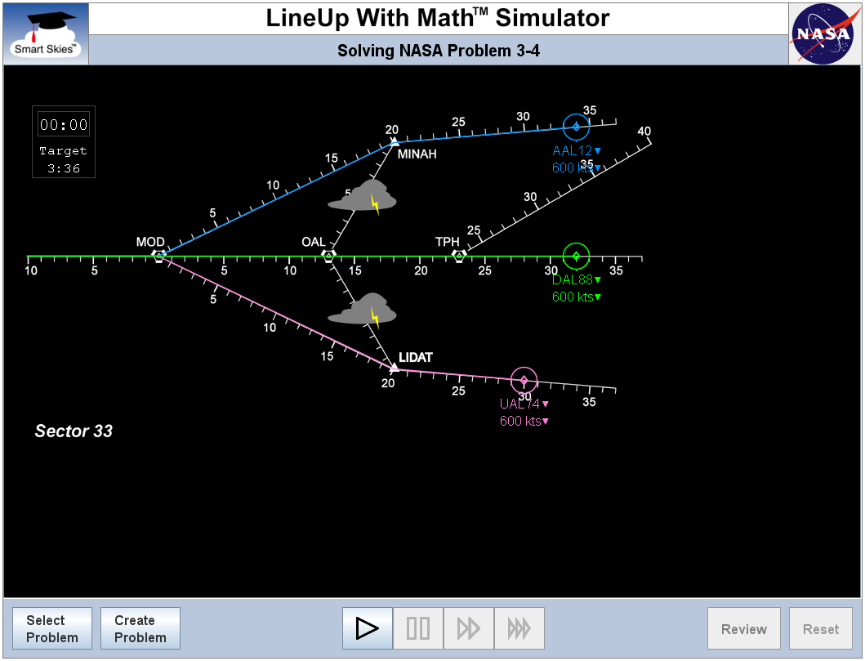
Routes Shown in Problem 3-4
- Re-create a rough sketch in your engineering notebook and show your work as you calculate the time when each pair of aircraft will collide.
- Change the velocities of each flight to avoid a midair collision. Change the velocities by selecting the arrow beside the velocity and clicking the new velocity.
- Click the Play button to test your proposal. Note that the scenario speed can be increased by clicking the 4X or 10X button .
- Did the aircraft pass through the MOD VOR safely? If so, congratulations on being a successful ATC. Make a screen capture of the end of the scenario with the slowest aircraft arriving at the MOD VOR. Skip the next step.
- If you did not successfully separate the aircraft, recalculate safe velocities, reset the scenario by clicking the reset button, and change the velocities to match your new proposal. Play the scenario to test your calculations. Repeat the above steps until the flights that you are responsible for complete their flight safely.
- Click on Select a Problem, 4 Planes, Problem 4-4. Follow the same process as above; however, consider altering the flight route. For example AAL12 can fly either the MINAH-MOD or MINAH-OAL-MOD route. To change the flight route, click the call sign and select the preferred route.
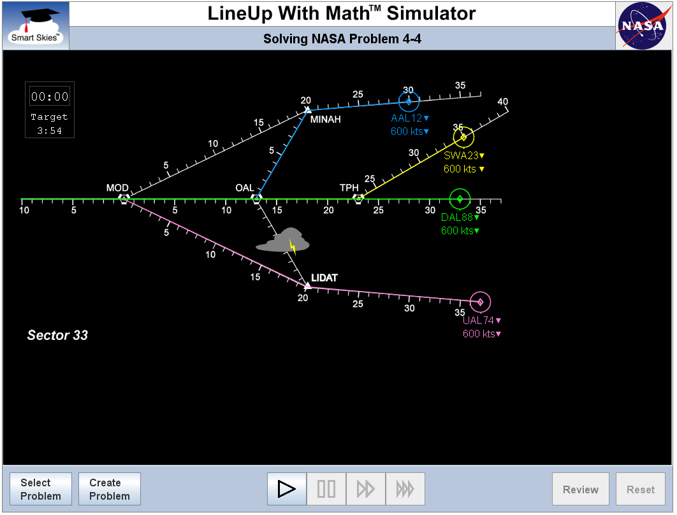
Routes Shown in Problem 4-4
- Submit your engineering notebook. Show all of your calculations and the screen captures of the successful arrival of flights at the MOD VOR.

Conclusion
- What variables do ATCs need to consider? What variables can they control when making decisions?
- How can the ATC system be improved?

