

Activity 2.1.2 Beam Deflection

Introduction

Engineers must look for better ways to build structures. Less material typically means that structures will be lighter and less expensive. Knowing the moment of inertia for different shapes is an important consideration for engineers as they strive to make designs lighter and less expensive.

Equipment

* 1- 2x4 (preferably straight, free of knots and imperfections)
* Dial calipers or a ruler with 1/32 divisions
* 2 - 1 foot lengths of 2x4 for use as supports
* Tape measure
* Permanent marker
* Floor scale
* Cinder block (Concrete Masonry Unit)

Procedure

You will determine the weight of one of your classmates using nothing more than a standard 2x4 and a measuring device. This activity will provide you with a better understanding of Moment of Inertia and how it can be used to determine the strength of beams.

Preliminary lab calculations to determine beam Modulus of Elasticity

1. Calculate beam Moment of Inertia

|  |  |  |
| --- | --- | --- |
| B – width of the beam (in.)  h – height of the beam (in.)  I – Moment of Inertia (in.4) |  |  |
| Vertical Orientation | Horizontal Orientation |
| I = | I = |

Position the beam as shown below.

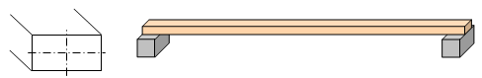

1. Measure the span between the supports. Record your measurement below.

Total Span (L) = __________in.

1. Measure the distance between the floor and the bottom of the beam.

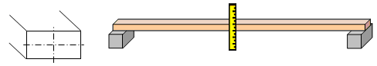

Pre-Loading Distance(DPL)= __________in.

1. Position a volunteer (V1) to stand carefullyon the middle of the beam. Have a person on either side of the beam to help support the volunteer.Measure the distance between the floor and the bottom of the beam.

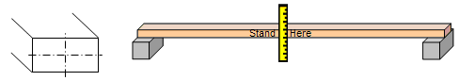

Applied Load Distance(DAL)= ___________in.

1. Calculate the maximum beam deflection (MAX).   
   MAX = DPL - DAL

MAX = __________ in.

1. Determine the weight of volunteer (V1) using the classroom floor scale.  
     
   Volunteer weight (F) ____________ lb
2. Calculate your beam’s Modulus of Elasticity (it is important to know that each beam will have its own specific Modulus of Elasticity) by rearranging the equation for beam maximum deflection to isolate (E). Show all work.

|  |  |
| --- | --- |
| Rearrange the equation  to solve in terms of E |  |
| Substitute known values |  |
| Simplify |  |
| Solve |  |

Note: An object’s Modulus of Elasticity is a material-based property and stays the same regardless of orientation.

Calculate volunteer (V2) weight

1. Position the beam as shown below.



1. Measure the span between the supports. Record your measurement below.

Total Span (L) = __________in.

1. Measure the distance between the floor and the bottom of the beam.



Pre-Loading Distance(DPL)= __________in.

1. Position asecond volunteer (V2) to stand carefully in the middle of the beam. Have a person on either side of the beam to help support the volunteer.Measure the distance between the floor and the bottom of the beam.



Applied Load Distance(DAL)= ___________in.

1. Calculate the maximum beam deflection (MAX).   
   MAX = DPL - DAL

MAX = __________ in.

1. Calculate volunteer (V2) weight by rearranging the equation for maximum deflection to isolate (F). Show all work.

|  |  |
| --- | --- |
| Rearrange the equation  to solve in terms of F |  |
| Substitute known values |  |
| Simplify |  |
| Solve |  |

Determining Beam Deflection

1. Using the information you collected and calculated in steps 1 – 14, calculate the max deflection of the beam if volunteer (V2) is positioned to stand on the beam in a vertical orientation.

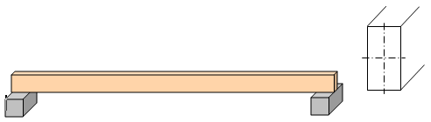

|  |  |
| --- | --- |
|  |  |
| Substitute known values |  |
| Simplify |  |
| Solve |  |

1. Verify your calculated max deflection answer and work to your instructor by having volunteer (V2) carefully stand in the middle of the beam. Place a person on either side of the beam to help support the volunteer.Measure the distance between the floor and the bottom of the beam.

Calculated deflection: _____________

Measured deflection: _____________

Instructor signature: ___________________________ Date: ________

**Practice Problem**

1. Complete the chart below by calculating the cross-sectional area, Moment of Inertia, and beam deflection, given a load of 250 lbf, a Modulus of Elasticity of 1,510,000 psi, and a span of 12 ft. Show all work in your engineering notebook.

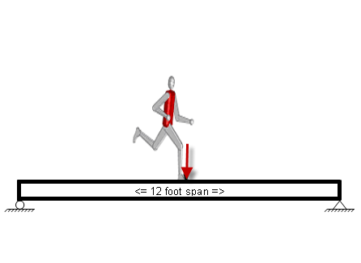

|  |  |  |  |  |  |  |
| --- | --- | --- | --- | --- | --- | --- |
| Beam | **A** | **B** | **C** | **D** | **E** | **F** |
| Common Name | **2x6** | **2x6** | **2x8** | **2x8** | **2x10** | **2x10** |
| Actual Dimensions (in.) | 1.5 x 5.5 | 1.5 x 5.5 | 1.5 x 7.25 | 1.5 x 7.25 | 1.5 x 9.25 | 1.5 x 9.25 |
| Vertical or Horizontal Orientation |  |  |  |  |  |  |
| Cross-Sectional Area (in.2) |  |  |  |  |  |  |
| Moment of Inertia  (in.4) |  |  |  |  |  |  |
| Beam Deflection  (in.) |  |  |  |  |  |  |

Conclusion

1. Using Excel, create a Deflection vs. Moment of Inertia graph. What is the relationship between moment of inertia and beam deflection?
2. How could you increase the Moment of Inertia (I) of a beam without increasing its cross-sectional area?