Activity 2.1.3 Free Body Diagrams

Purpose
In 1981 at a Kansas City Hyatt, a walkway holding hundreds of people collapsed during a party. The collapse killed 114 people and injured 200 others. When building this walkway, designers and engineers made serious errors that allowed the collapse to occur under the weight of so many people. In such a design, every part must be analyzed to ensure that it can perform its intended function without failing. One planning tool that engineers can use is the freebody diagram. Freebody diagrams show all forces that act upon a body or part. The information identified in a freebody diagram can be used to determine whether a part is adequate.

Procedure
In this activity you will practice creating freebody diagrams (FBD) in order to evaluate all of the forces interacting with those objects.

- Examine the image below. Draw a freebody diagram for both objects. Use the notation in the image as subscripts when labeling forces.

- Examine the image below. Draw a freebody diagram for the four labeled parts in the image. Use the notation in the image as subscripts when labeling forces.
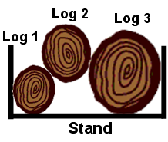

- Examine the image below.Draw a freebody diagram for the five labeled parts in the image. Use the notation in the image as subscripts when labeling forces.
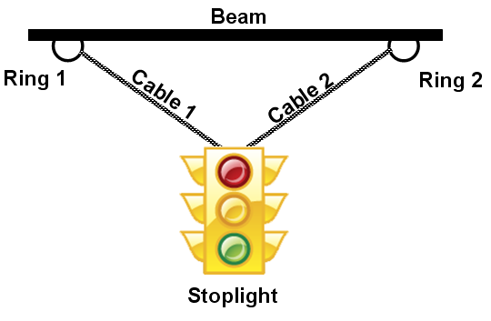

Conclusion
- Why is it important to createfreebody diagrams?

- Sketch a freebody diagram of the person sitting in a car seat as shown below. Which force arrows do you think would be the largest? Why?
