Activity 2.1.5 Preparing Composite Samples

Introduction
People have always associated metal airplanes with strength. However, aircraft designers today are turning to composite materials to meet the growing challenge of maintaining safety and economy for commercial air travelers. Anticipating this challenge, NASA and Boeing have joined forces under the NASA Advanced Composites Technology (ACT) program to make large composite airplane structures a reality.
You will work with a team to understand more about composites and how they are made. The materials that you produced will be tested and evaluated.

Equipment
- Rolls of fiberglass
  - Bidirectional fiberglass tape 2 in. wide
  - Unidirectional fiberglass tape 12 in. wide
- Protective gloves (i.e., vinyl, nitrile, latex – potential allergy risk)
- Scissors
- Tape measure
- Razor knife with long blade, such as Olfa type or hot wire cutter
- Mold apparatus
  - 8 pieces wood board 2 in. x 6 in. x 16 in.
  - 8 clamps
- Polyethylene sheet
- 1 piece 4 ft x 4 ft x 5 mil tabletop cover
- 8 pieces 6 in. x 16 in. x 5 mil mold covers
- Styrofoam
  - 2 pieces ½ in. x 2 in. x 12 in.
  - 2 pieces 2 in. x 2 in. x 12 in.

Procedure
- Form groups of 3 or 4 under direction from your teacher.
- Prepare the work area by protecting the table top with a 4 ft x 4 ft piece of polyethylene plastic.
- Prepare the fiberglass strips.
  - Use scissors to cut 16 pieces of 2 in. bidirectional fiberglass tape 12 inches long.
  - Use scissors to cut 12 pieces of unidirectional fiberglass tape 2 in. wide x 12 in. long.
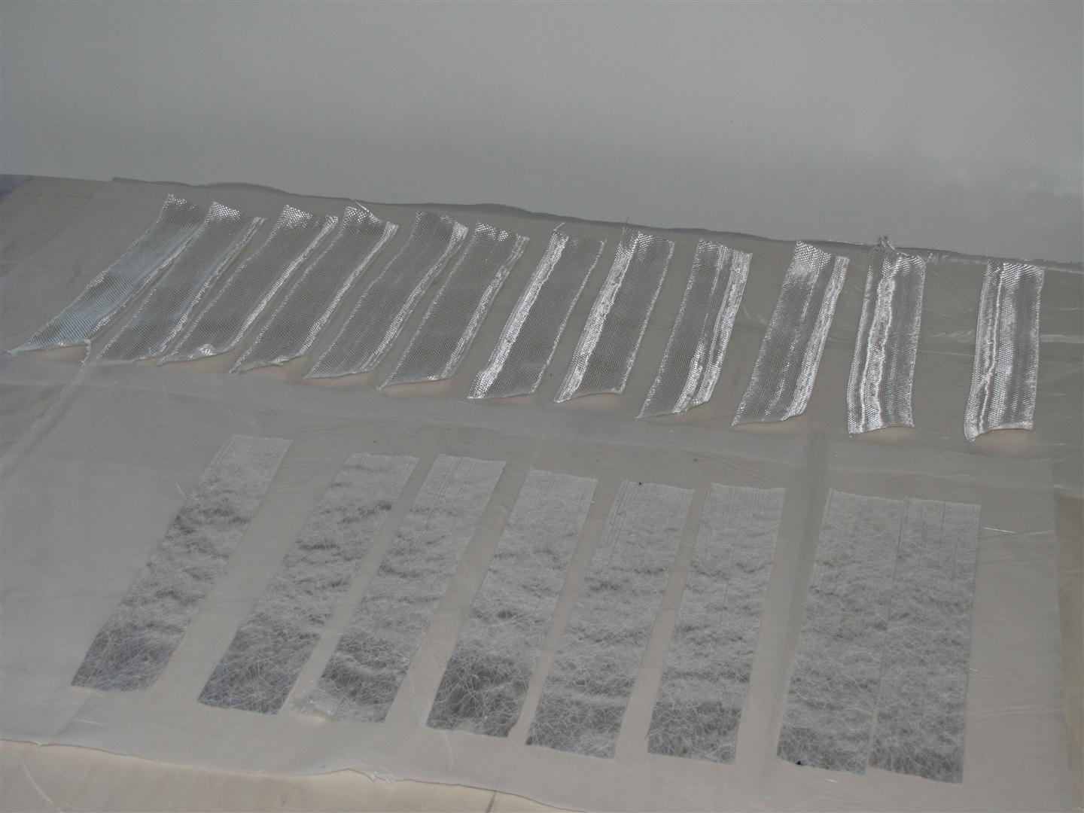
Fiberglass Samples
- Prepare the Styrofoam.
  - Cut 2 pieces of ½ in. thick Styrofoam sheet into 2 in. wide x 12 in. long pieces using a razor knife or hot wire cutter.Caution: Peel away any film from the fiberglass.
  - Cut 2 pieces of 2 in. thick Styrofoam sheet into 2 in. wide x 12 in. long pieces using a razor knife or hot wire cutter.
  - Cut 1 piece of 2 in. thick Styrofoam sheet into 4 in. wide x 12 in. long pieces using a razor knife or hot wire cutter. It is important to cut this block using two straight and parallel cuts. The fiberglass will be applied to this face.
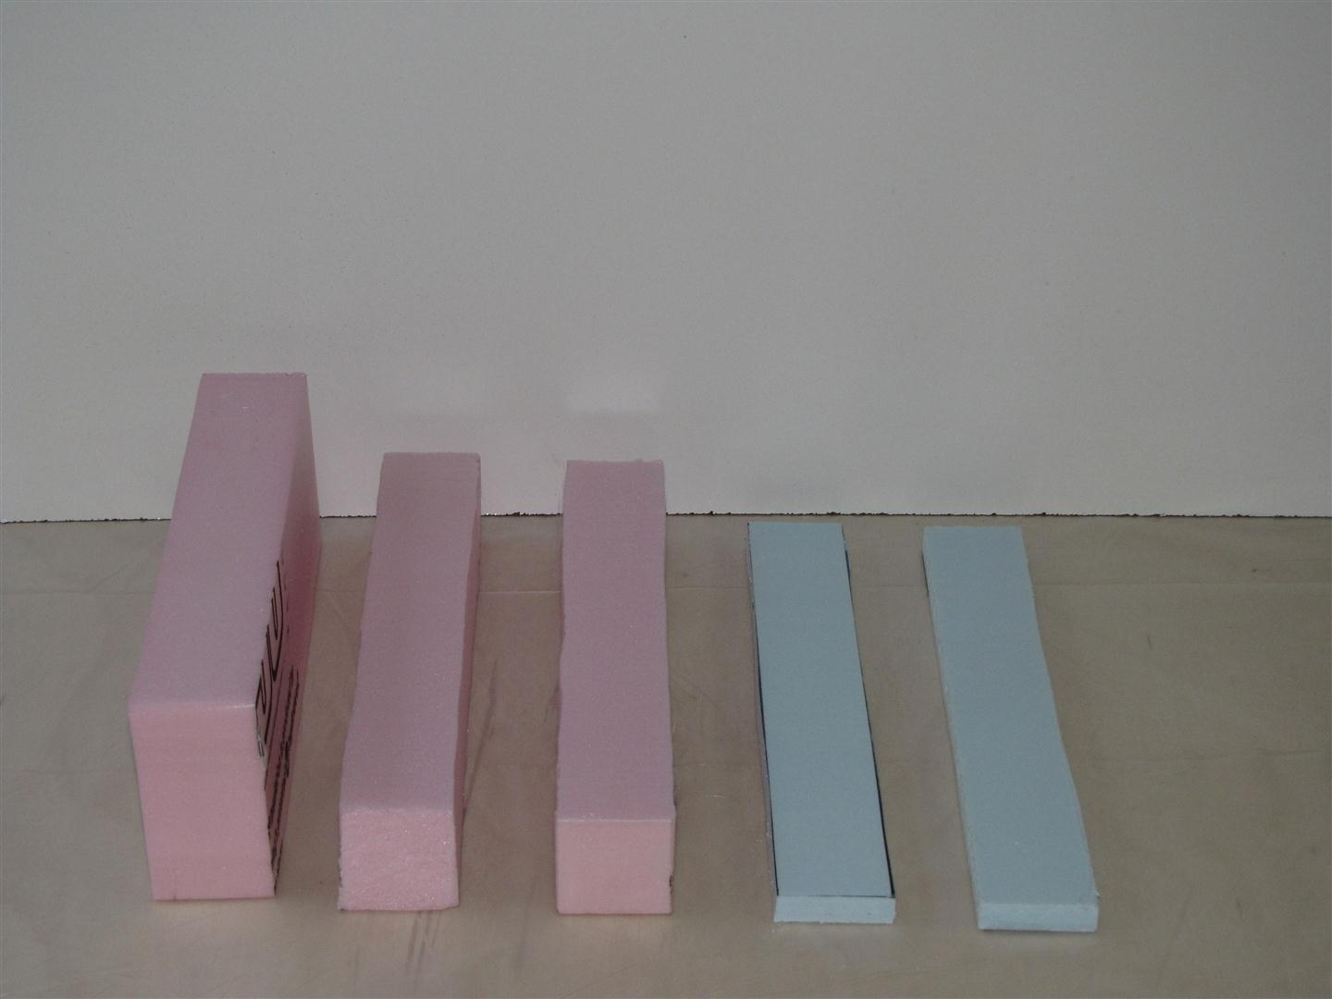
Styrofoam Blocks
- Prepare the mold apparatus.
  - Cut 8wood pieces that are 2 in. x 6 in. x 16 in.
  - Cut 8 pieces of a 5 mil polystyrene sheet into 6 in. wide x 16 in. long pieces.
- Store the glass, Styrofoam, and mold pieces in a clean area.
- Keep the resin cup to determine when curing is complete.

Conclusion
- List five products that could benefit from the lightweight and stiffness of composite plastics.
- Do the fibers (i.e., fiberglass or carbon fiber) in a composite contribute tensile or compression strength to a composite plastic?
- Comparing the properties of composite plastics and sheet metal, why aren’t cars made using composites?
- What effect would an increased use of composites have on the environment?

