Activity 1.3.3 Thermodynamics

Introduction
Think back to the last time someone complained about a door being left open. What did you notice about the temperature within the room as a result of the open door? In Activity 1.3.3 you will investigate the effects of work, thermal energy, and energy on a system, as in the case of the room with the door left open.

Procedure
Answer the following questions as your teacher discusses the Introduction to Thermodynamics presentation.

- Define thermodynamics.

- List three examples of a thermodynamic system.

- Define thermal energy.

- Define temperature.

Scale | Freezing point of water | Boiling point of water
Celsius
Fahrenheit
Kelvin
- Fill in the table below with the correct scale and unit.

- Define absolute zero.

- Define thermal equilibrium.

- Define the Zeroth Law of Thermodynamics.

- Define the First Law of Thermodynamics.

- List two ways thermal energy can be increased in a system.

- Define the Second Law of Thermodynamics.

- Define entropy.

- Define convection.

- List two examples of convection.

- Define conduction.

- List two examples of conduction.

Conduction Equations:
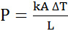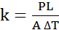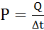

- Define the following variables.
Q =

m =

c =

P =

Δt =

k =

A =

L =

ΔT =

(18–22) A 1.00 kg piece of aluminum metal at 90.0 °C is placed in 4.00 liters (= 4.00 kg) of water at 25.0 °C. Determine the final temperature (T_{f}).

- List all known values.

- List all unknown values.

- Select equations.

- Apply known values.

- Solve.

(23–27) The top of a 3/16 inch thick acrylic testing box is covered with an unknown ½ inch insulation material (black). The dimensions of box are 10 inch x 10 inch on each side. The sides and are wrapped with a control insulting material (blue) so that the almost all heat loss is through the 10 inch x 10 inch unknown insulating material on the top of the box (assume no heat is lost from the bottom or sides of the box). Determine the thermal conductivity for the insulating material if a 25 W bulb is used to heat the box. You may assume the only heat loss from the box occurs through the 10 x 10 test area. The bulb maintains the inside temperature at 10 ºC higher than the outside temperature.
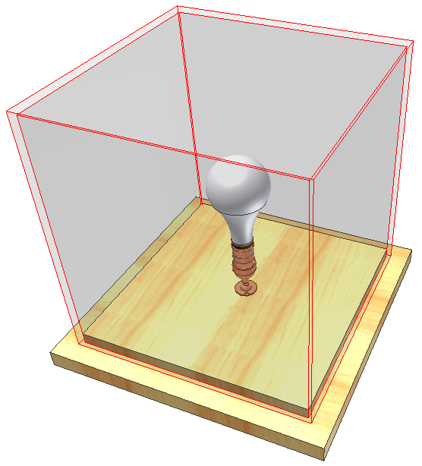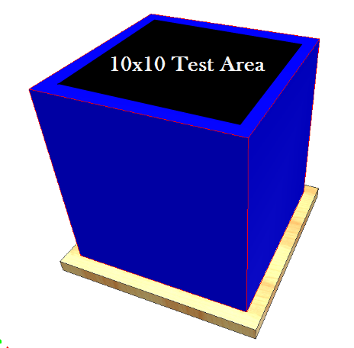
- List all known values.

- List all unknown values.

- Select equations.

- Apply known values.

- Solve.

- Define U-value.

- Define R-value.

(30–31) Use the provided R-value chart and the illustration below to calculate the R-value of the wall cavity and the R-value at the stud location.
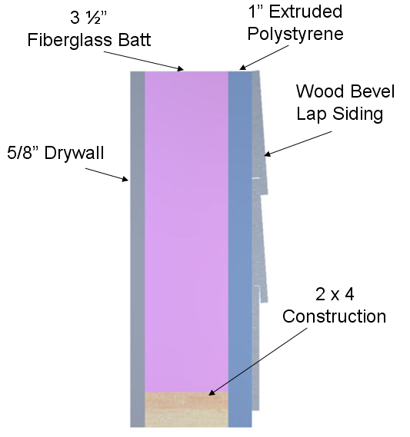
- Wall cavity R-value

- R-value at stud location

- Define radiation.

- List two examples of radiation.

- Define Stefan’s Law.

(35–39) A student travels on a school bus in the middle of winter from home to school. The school bus temperature is 58.0 °F. The student’s skin temperature is 91.4 °F. Determine the net energy transfer from the student’s body during the 20.00 min ride to school due to electromagnetic radiation. Note: Skin emissivity is 0.90, and the surface area of the student is 1.50 m².

- List all known values.

- List all unknown values.

- Select equations.

- Apply known values to equations.

- Solve.

- Define geothermal energy.

R-Value Chart
Construction Material | R-Value
½ in. Drywall | 0.45
5/8 in. Drywall | 0.56
Particle Board – ½ in. | 0.63
Particle Board – ¾ in. | 0.94
Fiberboard ½ in. | 1.32
Extruded Polystyrene 1 in. | 4.00
Extruded Polystyrene 1 ½ in. | 6.00
Foil-faced Polyisocyanurate 1 in. | 7.20
2 x 4 | 4.38
2 x 6 | 6.88
Hardwood | 0.90
Masonry Systems | R-Value
Brick 4 in. common | 0.80
Brick 4 in. face | 0.44
Concrete Block – Normal wt. 12 in. empty core | 1.23
Concrete Block – Light wt. 12 in. empty core | 2.60–2.30
Cement Mortar | 0.20
Sand and Gravel | 0.60
Stucco | 0.20
Roofing | R-Value
Asphalt Roll | 0.15
Asphalt Shingle | 0.44
Slate | 0.05
Wood | 0.94
Siding | R-Value
Wood Shingles | 0.87
Wood Drop | 0.79
Wood Bevel Lapped | 0.80
Aluminum/Steel – Hollow | 0.61
Aluminum/Steel – with 3/8 in. Backer | 1.82
Insulation | R-Value per in.
Fiberglass Batt | 3.142
Blankets – Rock Wool | 3.0–3.8
Loose Fill – Cellulose | 2.8–3.7
Loose Fill – Fiberglass 0.7 lb/cu.ft | 2.2–4.0
Loose Fill – Rock Wool | 3.1
Loose Fill – Vermiculite | 2.2
Extruded Polystyrene | 4.00

