Activity 2.1.4 Calculating Force Vectors

Introduction
If guy wires are used to stabilize a tower, what is the minimum number of wires necessary? Imagine what would happen if you only used one or two wires. The guy wires work together so that the tower does not fall in any direction. As long as there are no external forces and the wires are equally spaced, each of the wires should be experiencing an equal amount of tension. The tension in each guy wire can be expressed as a vector force. It is important that values are given for each force so that engineers can make informed decisions about the necessary strength of guy wires and their support mechanisms.

Equipment
- Calculator

Procedure
In this activity you will calculate force vectors.

- What is the magnitude of vector A? | 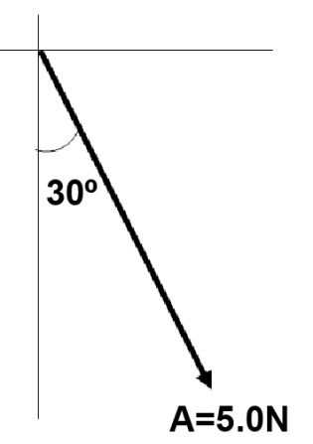
- What is the direction of vector A relative to the negative y-axis?

- What is the sense of vector A?
- Sketch vector A with itsx and y components(Solve for component forces with a precision of 0.0)

- What is the magnitude of vector B? | 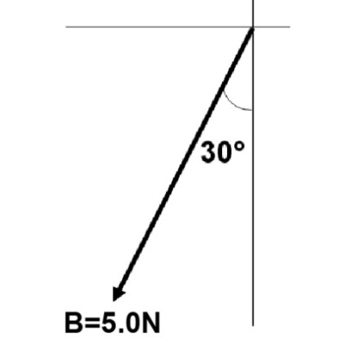
- What is the direction of vector B relative to the negative y-axis?

- What is the sense of vector B?

- Sketch vector B with itsx and y components(Solve for component forces with a precision of 0.0)

A picture is hung from a nail with wire. The nail supports two forces A = 5N and B = 5N.
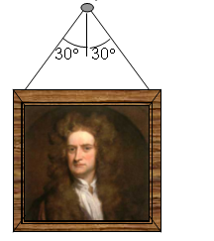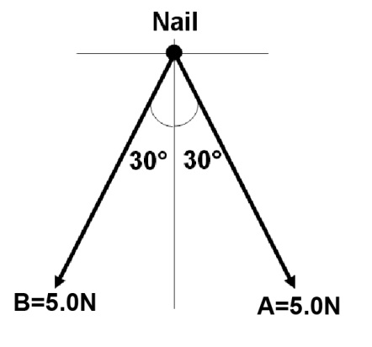
- Draw a free body diagram of the nail, illustrating the x and y components of vector A and B. (Solve for component forces with a precision of 0.0)

- Calculate the x and y components of the resultant force (R) by summing the x and y components of vectors A and B.
ΣF_{x} = F_{Ax} + F_{Bx}ΣF_{y} = F_{Ay} +F_{By}

An eye screw is experiencing two tension forces G=100N and H=50N.

- Sketch vector G with itsx and y components.(Solve for component forces with a precision of 0.0)
- Sketch vector H with itsx and y components.(Solve for component forces with a precision of 0.0)
- Calculate the sum of thexandy components of vectors G and H. (precision of 0.0)
ΣF_{x} = F_{Gx} + F_{Hx} |  |  | ΣF_{y} = F_{Gy}+ F_{Hy}
- If you know the components of a vector, what mathematical relationshipcan be used to find the magnitude of the vector?

- Sketch the resultant force (R) and calculate the magnitude and angle of the vector. (precision 0.0)

Conclusion
- You and someone else are pulling with forces of equal magnitude. You each pulling at an angle of 25° from the X axis (see top view below). How could you reduce the amount of force each of you must exert?
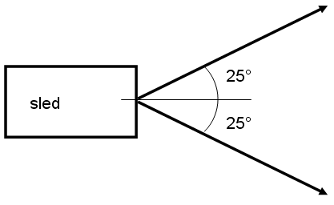

- You and someone else are pulling on an object with forces of 50N and 75N respectively. If you are allowed to pull in any direction, what range of values is possible for the magnitude of the resultant force?

