Activity 2.1.8 Truss Design – VEX

Introduction
Truss design often occurs in large structures like building roof supports and bridges. Trusses can be designed in any number of ways, based upon constraints and expectations. One important consideration is how much a truss design weighs versus the load that it is capable of supporting. It is crucial that designers weigh all such factors to create a design.

It is important to create accurate and detailed documentation of designs and test results. Recording shapes, dimensions, failure loads and locations, and efficiency calculations are important. Record these figures so that one design can be compared to other designs, results can be replicated, and solutions can be communicated to other individuals.

Equipment
- Truss testing device – see Building a Testing Device with VEX
- 4 - 3/32 x 3/32 x 36 in. balsa sticks per team
- Graph paper
- Wood glue
- Utility knife (razor)
- Scissors
- Transparent tape

Procedure
In this activity your team of four willfabricate four small trusses, two of each design. Youwill perform destructive tests of each. Throughout this process you will document your design, its test results, and failure point locations on graph paper which can be transferred to your engineering notebook. Study the truss designs below, andthen follow the procedure in the table to construct and record test results for each design.

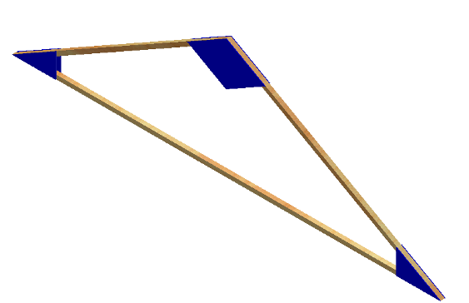
Truss Dimensions
Truss #1

Truss #2
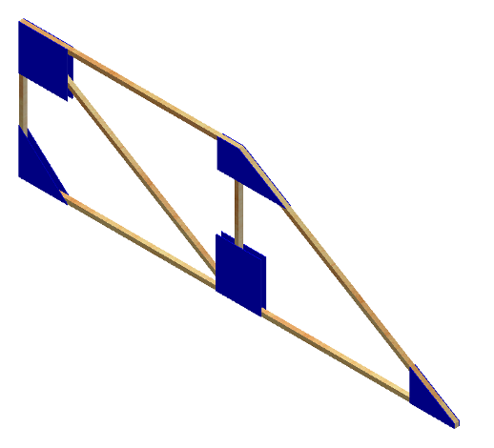

Truss Construction Procedure
- Create a template of truss1 on a sheet of graph paper. Use an overall width of 9.75 in. and an overall height of 2.75 in.  Be sure the bottom member spans the entire width of the truss | 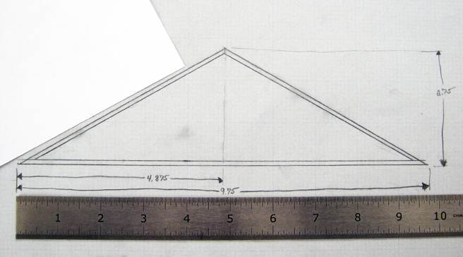
- Using the template you’ve created, cut each member from pieces of 3/32 in. x 3/32 in. strips of balsa wood.  Larger sizes of balsa or wood or substituting bass wood could result in trusses that exceed the limits of the dual range force sensors. | 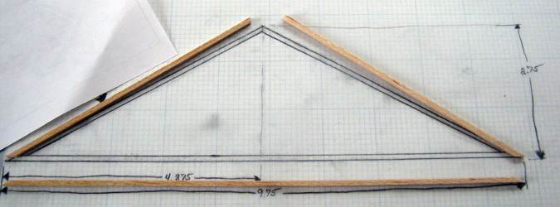
- On a new sheet of graph paper, create two footprints of the truss using the same measurements from step1.  These graphs will tear when the glue from the trusses dries on it. By creating a footprint on a second sheet, the original can be used to record the design, failure points, and test data. | 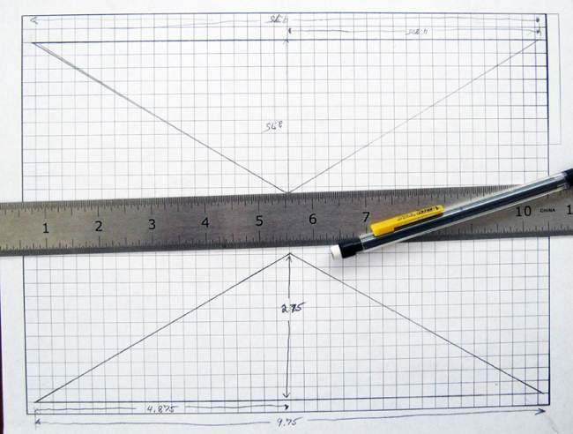
- Place the bottom member on the footprint using the lines as a guide. Use small pieces of clear tape to straighten the member and hold it in place. Straight members will allow you to truly test the design of the truss.  Keep tape at least 1 in. from joints to allow for gussets to be glued on later. | 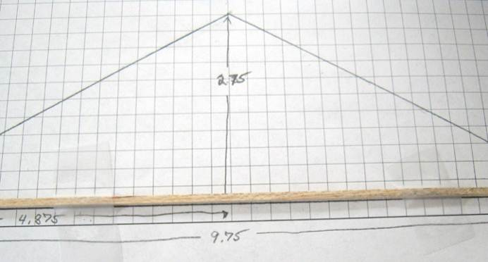
- Repeat the previous step for each additional member. Before taping each additional piece, first place a small amount of wood glue on each member where it will connect to another member.  Be sure to pull the joint tight and squeeze out any excess glue. More glue does not create a stronger bond; however, pulling the joint tight can create a bond stronger than the wood itself. | 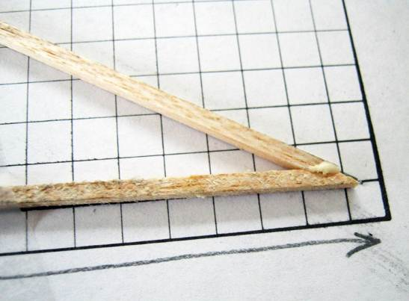
- Wipe off any access glue and makesure the joint is pulled tight. Extra pieces of tape can be applied to provide pressure to pull the joints tight. | 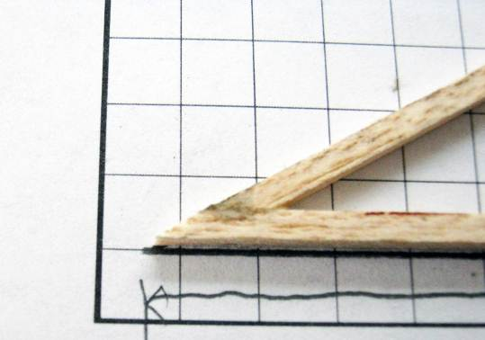
- Gussets provide extra support at joints to prevent failurewhere members under tension or compression meet. Cut out the gussets on the last page of this activity

- Place a light layer of glue along each member near its joint where the gussets will cover. Then place the front gussets over the glue. Gussets are only needed on one side of the truss.  While the glue dries, repeat the process for the second model of truss1and both models of truss2. | 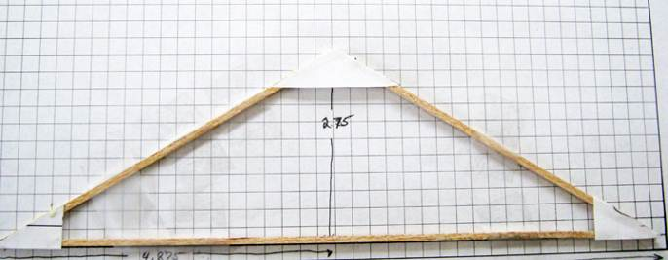
- After glue dries (30 min) remove the tape and use a razor to free the bottom of the truss from the graph paper. Then glue the gussets on to the back.  *Allow the members and gussets to completely dry overnight. | 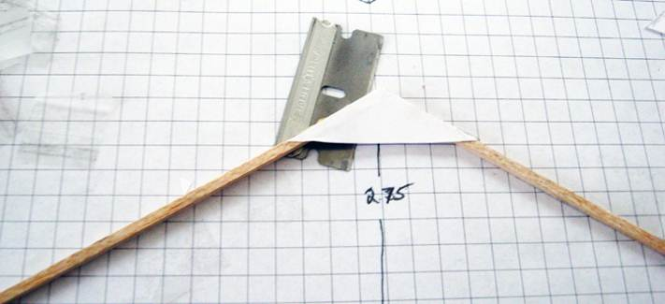
Well-built trusses will result in meaningful test results. Trusses that fail due to breaks at joints do not reflect the strength of the design. A pocket of dried glue will crack at stress levels that trusses should be able to support. A good break occurs generally in the middle of a member due to compression or tension forces.

Testing the Trusses
- Prior to testing each truss, weigh the truss and record the value in the Truss Efficiency Table below.
- Follow the procedure from the Truss Tester Assembly and Procedure document to complete a destructive test of each truss.
- During Testing: Use your original template to record the force loads and locations of failure during testing. When complete, tape the template and data in your engineering notebook. | 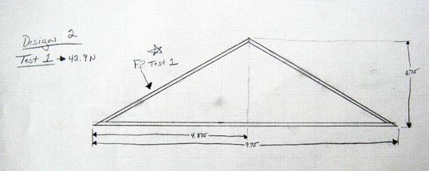
- At the end of each test and before clearing the data from Logger Pro, Print the graph and image and tape in your engineering journal next to the template of the truss design.

Truss Efficiency Tables:
To evaluate the efficiency of one design versus another, we will compare how much force each truss was able to withstand with the amount of material used to construct the truss (weight).

It is not necessary to convert the weight and force values into a common unit of measure. By dividing the load (measured in Newtons) by the weight of the truss (measured in grams), you are calculating the amount of force in Newtonssupported per unit weight of material.

Truss 1 | W =Weight of truss (g) | F =Force applied at failure (N) | Efficiency calculation (F / W)
Model 1
Model 2

Truss 2 | W =Weight of truss (g) | F =Force applied at failure (N) | Efficiency calculation (F / W)
Model 1
Model 2

Additional Calculation
In your engineering notebook, use the maximum force value for each truss and calculate the reaction forces occurring along with the forces that each member underwent at failure. Detail how each truss broke and record assumptions about why each broke. Was there a correlation between the forces that you calculated at each member and how the trusses broke?

Truss Design Challenge
Your team will design a truss that can be tested using the test apparatus for efficiency. You will use the same materials utilized to build the smaller trusses. Your truss will be evaluated for quality and efficiency. Efficiency is based on the weight of your truss versus the force exerted at failure.

- As a class discuss the challenge and determine constraints based upon materials and the testing apparatus. Record all of this information in your engineering notebook.
- Research and discuss possible solutions for your design as a team. Use the documentation procedures you used for the first two truss designs.
- Sketch three possible solutions, estimate the force you believe each might support, and calculate all internal and external forces that will occur based on that estimate in your engineering notebook. Be sure that all of your designs are statically determinate.
- Based on the three possible solutions that you sketched, create a final truss design. Calculate all forces for that design and submit to your instructor for approval.
- Create and test your final design and record the results in your engineering notebook. Include a reflection regarding the design and test. Include notes about how you could improve the design based on your data and testing observations.

Truss 3 | W =Weight of truss (g) | F =Force applied at failure (N) | Efficiency calculation (F / W)
Model 1
Model 2

Conclusion
- Explain why you think failure occurred at the truss member where it did. Did your truss fail at the member that your calculations revealed as undergoing the most stress?

- If given a chance to redesign your truss after testing, what changes would you make?
Truss 1 Gusset Plate Templates (two sets)

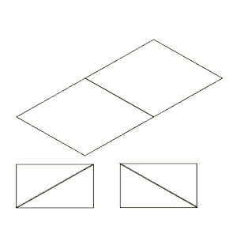

Truss 2 Gusset Plate Templates (two sets)

