Project 2.2.3 Turbine Engine Design Template

Screen capture or photograph of your project

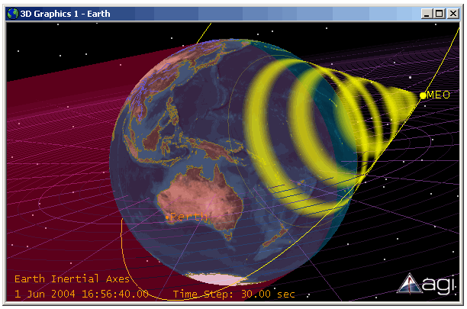
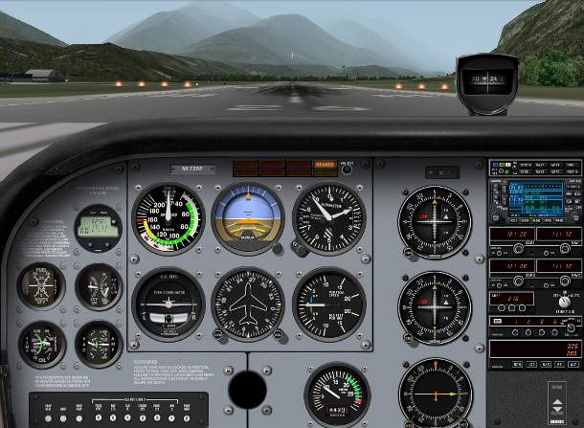
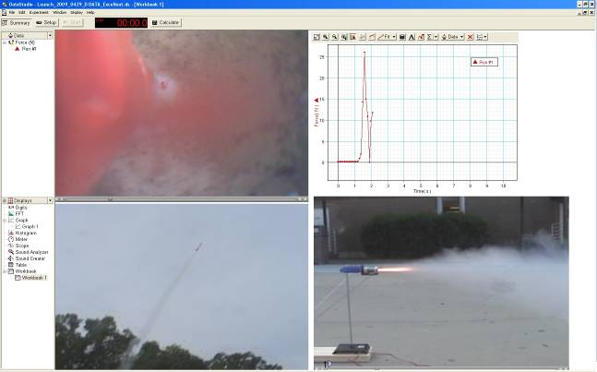

Your Name(s)
Class Period
Instructor’s Name
Date

Directions: All words in blue italics must be replaced with your own information and changed to black non-italic font.

Abstract:
Provide a brief description of the overall project. Answer questions such as:
- What was the purpose of the project?
- What specifications did the product need to meet?
- How much time was spent on the project?

Concepts:
List and explain the major concepts addressed in the project. Every project is intended to address major concepts or central themes in the curriculum. You are to identify and explain those concepts here including:
- Explain how each section (intake, compression, power, exhaust) of a turbojet engine works in words with hand sketched diagrams. Do not copy and paste a picture from an Internet source.
- If the design included an afterburner, a turbofan or a ramjet, explain how the design is different from a basic turbojet engine in words with hand sketched diagrams. Do not copy and paste a picture from an Internet source.
- Define all terms listed in Step 8 of the project document in your own words. Do not copy and paste a picture from an Internet source.

Technical Documentation:
- In a table, summarize your final design choices for steps 1-6 of the project document.
- In a table and using the Engine Performance Output, summarize all the data for the design as specified in Step 8 of the project document.
- Using the Component Performance Output, hand-draw a picture of the engine and number the stages. For each stage, show its pressure and temperature with units.

Discussion:

Using the data above and your understanding of the data, explain why your design should be selected as the most fuel efficient. Show a detailed understanding of the terms and the data. This should be the most detailed section of your report.

