Project 2.2.5 Rocket Design and Build

Introduction
Rockets are designed for a variety of missions and performance requirements. The payload of a rocket is that crucial component that often provides the constraints for the engine thrust and flight control.

In this projectyou will design and build a rocket to perform a mission specified by your teacher. The thrust available is limited to the engine you tested in the last activity.

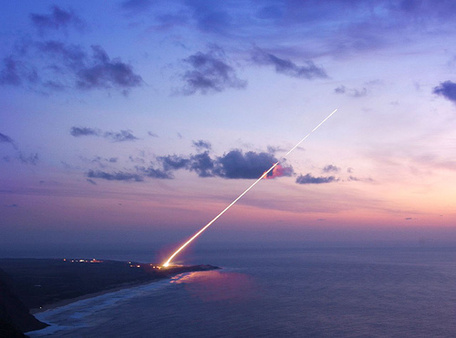

Equipment
- Engineering notebook
- Computer with access to NASARocketModeler software
- Rocket tubes (Inner and outer diameters)
- Nose cone
- Parachute
- Rocket engine
- Clay
- String (10 ft masonry line)
- Weighing scale

Procedure
- Form three person teams under the direction of your teacher.
- Your teacher will provide you with the design objective and constraints. Record the information below.
  - Rocket engine: _________________.
  - Maximum rocket weight at launch: _________________.
  - Rocket tube minimum and maximum diameter: _________ and ________.
  - Parachute: ______________
  - Payload description: _________________.
  - Maximum payload weight: _________________.
- Weigh each component that will be included in your rocket. Record the weights below.
  - Nose Cone: _____________
  - Launch lug: _____________
  - Outer tube (per inch): _____________
  - Inner tube (per inch): _____________
  - Fin material (per square inch): _____________
  - Rocket engine: _____________
  - Parachute with shroud lines: _____________
  - Additional item #1: _____________
  - Additional item #2: _____________
  - Additional item #3: _____________
- Start the NASARocketModeler software.Below are summarized instructions to use the software. Complete software instructions are available at: http://www.grc.nasa.gov/WWW/K-12/rocket/rktsim.html.
- Below is the explanation for the color codes in the display.
  - Blue buttons are option buttons to select.
  - Yellow indicates your current selection.
  - White buttons are processes to complete to launch your rocket.
  - Green indicates that the process is Go for launch.
  - Red buttons demand immediate attention or Aborts the mission. The red Reset button returns values initial condition.
  - A white box with black numbers is an input box.
  - A black box with colored numbers is an output box computed by the software.Red numbers indicate trouble.
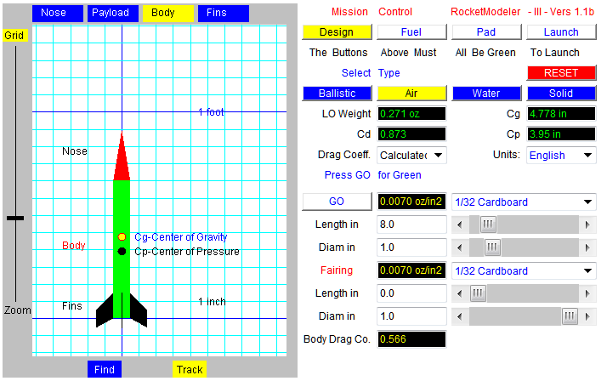
- Build your rocket system including each component using the design objective and constraints provided. Your rocket will be different than the example above. The processes align to full scale rocket design.
  - Click Solid to design for the use of solid rocket engines. Click Nose above the rocket graphic and enter the rocket parameters. Proceed to enter the rocket parameters Payload, Body, and Fins. Click Go when the Design parameters are entered correctly. This step may be returned subsequently.
  - Click Fuel and enter the rocket parameter. Click Go when the Fuel parameters are entered correctly.
  - Click Pad and enter the launch data. Note that several scenarios may be required to predict the launch conditions. Click Go when the Pad parameters are entered correctly.
  - Click Launch to enter the rocket performance simulation. Click Fire to simulate the rocket flight. Click Track to display the rocket during the simulation.
- Screen capture each screen of the Design, Fuel, Pad, and Launch results for your final report.
- Construct the rocket designed under the direction of the teacher.
- Assemble the rocket as if it was to be launched.
- Locate and mark the center of gravity.
  - Tie a slip loop on the end of 10 ft of string
  - Place the rocket into the loop.
  - Slide the loop along the rocket until it remains balanced without more support than the string.
  - Mark this rocket center pointwith a CG label.
- Primary test for rocket stability.
  - Tighten the slip loop at the center of gravity
  - Place a small piece of tape to secure the string.
  - Hold the end of the string in one hand above your head.
  - Hold the tail of the rocket in the free hand.
  - Swing the rocket in a horizontal circle. This will typically require a few attempts before it will swing freely.
  - If the rocket flies straight then it passed the primary stability test and the rocket is ready for the secondary rocket stability test.
  - If the rocket fails the primary stability test then the center of gravity can be moved towards the nose by adding clay to the nose or the fin area can be increased.
- Secondary test for rocket stability.
  - Adjust the string so the rocket nose dips down 10 degrees from the horizontal.
  - Place a small piece of tape to secure the string.
  - Hold the end of the string in one hand above your head.
  - Hold the tail of the rocket in the free hand.
  - Swing the rocket in a horizontal circle. This will typically require a few attempts before it will swing freely.
  - If the rocket flies straight then it passed the secondary stability test.
  - If the rocket fails the secondary stability test then the center of gravity can be moved towards the nose by adding clay to the nose or the fin area can be increased.
- Prepare a report of the rocket design and predicted performance.
- The rocket will be launched in the next project.

Conclusion
- Explain how the mission influenced the design process.
- Explain some of the design challenges you faced.

