Project 2.2.8 Space Propulsion

Introduction
Space craft face an environment quite different than aircraft. The first phase of propulsion requirement requires a transition from rest on the ground to passing upwards through the atmosphere through a thinning atmosphere enroute to space. Then the spacecraft must maneuver within the vacuum of space. Depending on the mission this is the final phase or the spacecraft reenters the Earth’s atmosphere or the atmosphere of the destination.

In this project you will research and present to the class a spacecraft propulsion system.
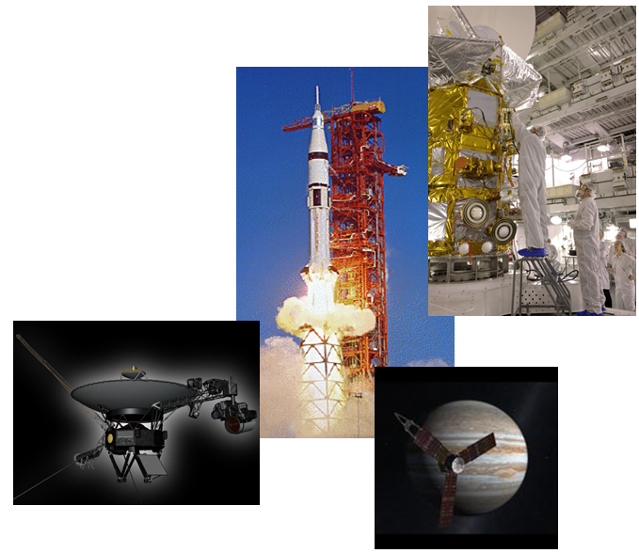

Equipment
- Computer with presentation software
- Engineering notebook
Procedure
- Form two or three person teams under the direction of your teacher.
- Prepare a 10 minute presentation for your peers about your chosen system. The subject must be unique from your colleagues. Example topics and content are listed below.
  - Topics
    - Cold Gas
    - Solid Fuel
    - Liquid Fuel
    - Monopropellent
    - Bipropellent
    - Dual mode
    - Hybrid
    - Electric
    - Nuclear
    - Solar Sail
    - Reaction Wheels
    - Moment Exchange Tethers
    - Electrodynamic Tethers
  - The presentation should the following information.
    - How the system creates propulsion.
    - The main components of the system.
    - Situations where this type of system would be appropriate or the most efficient choice.
    - How the energy is converted from fuel form to propulsion.
    - The amount of fuel used to make attitude adjustments.
- Present your research results to your peers.

Conclusion
- Explain how expansion of a fluid being propelled from the space vehicle is related to Newton’s Laws.
- Explain how life span of the vehicle is dependent on the amount of fuel it has and how quickly it is used.

