Activity 3.6 Instant Challenge: Fling Machine

Introduction
There are many ways to solve a problem. Sometimes it is as simple as applying a piece of duct tape. Other times it takes months or years for a product to progress from an idea into full-scale production. In this activity your team will quickly design and build a device that will send a cotton ball as far as possible through the air.

Equipment
- Paper
- Pencil
- Scissors
- timer

Materials(may vary)
- 1 cotton ball
- 1 balloon
- 1 rubber band
- 2 paper clips
- 1 piece aluminum foil (12"x12")
- 1 tongue depressor
- 2 straws
- 2 pipe cleaners
- Hot glue
Procedure
Using only the materials provided, design and build a device to launch a cotton ball and send it as far as possible.
- Your team will have 15 minutes to devise a solution and document the solution both in writing and in graphical form with a drawing.
- Your team will have 10 minutes to build your solution.
- Your team will have 20 minutes to test your solution. Record the distance traveled by the cotton ball (to the nearest inch) for ten attempts.
- Finally, your team will have one attempt to demonstrate your solution to your classmates.
- Use the design process learned in Unit 1. Document each step in your engineering notebook as you complete this design challenge.

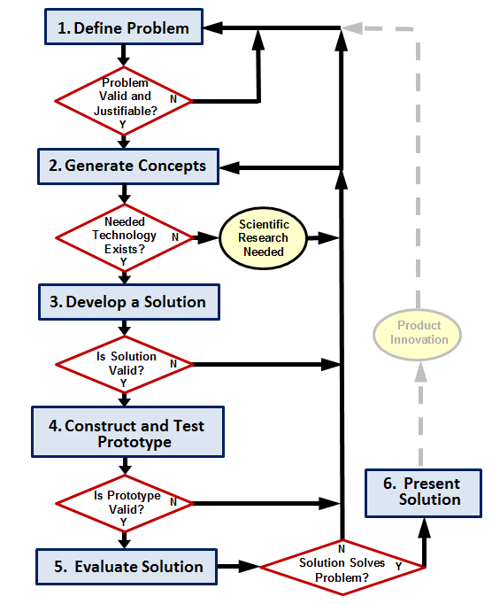
Constraints
- You may not wrap your cotton ball inside the aluminum to make rigid projectile, the cotton ball must remain fully visible.
- Your design must incorporate ALL materials.

Scoring
Your team may receive points for the following.
- Creativity: Up to 10 points for creativity in the design and use of materials.
- Teamwork: Up to 10 points for how well your team works together.
- Performance: Using the landing point of the cotton ball that was propelled the furthest from the launch device, 2 points for each inch between the device and the point at which the cotton ball lands.

Conclusion
- Analyze the cotton ball travel distance data that you collected.
  - Create a histogram of your data using five class intervals.

  - Is the data normally distributed? Justify your answer.

  - Calculate the mean, median, range and sample standard deviation of the travel distances of the cotton ball.

  - Give a range of travel distances within which you would predict that 95% of all cotton balls launched with your device would fall. For example, you might predict that 95% of the cotton balls that you launch would travel between 2.25 ft and 3.00 ft. Justify your answer.

- Do you feel that the statistical analysis results would be a better measure of performance when comparing alternate devices than by simply using the distance traveled by a cotton ball in a single attempt? Why or why not?

- Would you recommend using the results of your statistical analysis of travel distances to assess your devices performance, rather than using it to predict the distance a single attempt will travel? Why or why not?

- If you had the opportunity to optimize your design, how would you increase the distance that the cotton ball moves?

- If you had the opportunity to optimize your design, how would reduce the amount of materials used?

- How could you improve the effectiveness of your team?

