Activity 5.6 Physical Property Analysis

Introduction
What do you need to know about a product before it is built? Would you need to know its volume, surface area, or weight?Would the product weigh less if it were made of aluminum or mild steel? What about copper, brass, or cast iron?How could this information impact the product design?

How can you find the properties of a product before it is built? You can calculate them mathematically, providing you have the material specifications, but it will take time. In today’s busy, fast-paced world, engineers use solid modeling software programs to speed up the calculating process. However, the user of the software must understand what the software is doing in order to estimate the answers and to be able to recognize a possible error.

Equipment
- Engineering notebook
- Pencil
- Computer with 3D CAD solid modeling software
- Calculator

Procedure
In this activity you will calculate the volume of a part and the surface area; you will look up the density of the material and then calculate the mass. Next, you will check your work using a 3D solid modeling software program. After you have learned how to calculate the physical properties of the example parts provided, you will then do an analysis on a puzzle cube piece and parts of your Automoblox vehicle or other consumer product.

Aluminum Object Example 1

The aluminum example is provided as an isometric drawing that will need to be created as a solid model. The grid spacing for the object shown is 0.25 inch. Using the grid, determine the measurements for each facet of the part. Create a model of the object with the required geometry using the 3D solid modeling software. You will assign aluminum as the object’s material and perform a physical property analysis to determine the answers to the questions. Record the CAD Physical property values in your notebook. When you have completed the physical property analysis, answer the questions below.

You may need to review your notes and the Physical Properties PowerPoint to recall how to generate the physical properties of a part.

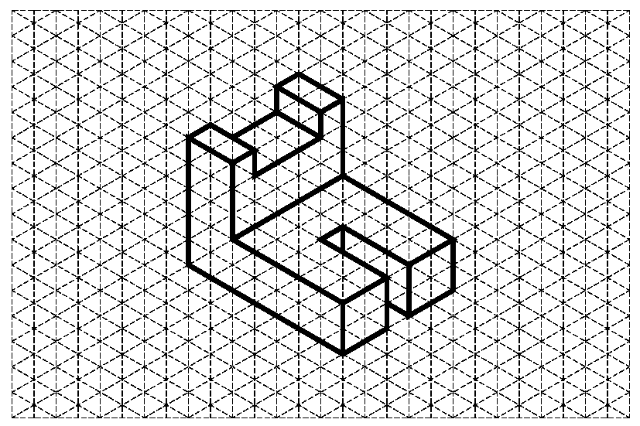
Figure 1: Isometric drawing of Aluminum Object One with 0.25” grid

Questions for Aluminum Object One
- What are the physical properties presented in the CAD software? Include units.
A. Density _______________
B. Mass _______________
C. Surface Area _______________
D. Volume _______________

- Use the internet to research the accepted value for the density of aluminum in grams per cubic centimeter? Be sure to document your source.

- Convert the density of aluminum into pounds per cubic inch. Show your work including all conversion factors.

- If one quart of cleaning solution will clean 14,400 in², how many quarts will be required to clean 3000 of these aluminum parts? Use 3D software physical properties.

- 2.000
- 1.500
- 2.135
- 2.145

SHOW WORK:

Brass Object Example 2

An isometric drawing of a brass part is provided. The grid spacing for the object shown is 0.25 inch. Using the grid, determine the measurements for each facet of the part. Create a model of the object with the required geometry using the 3D solid modeling software. You will assign brass as the object’s material and perform a physical property analysis to determine the answers to the questions. Record the CAD Physical property values to hand in with this packet. When you have completed the physical property analysis, answer the questions below.

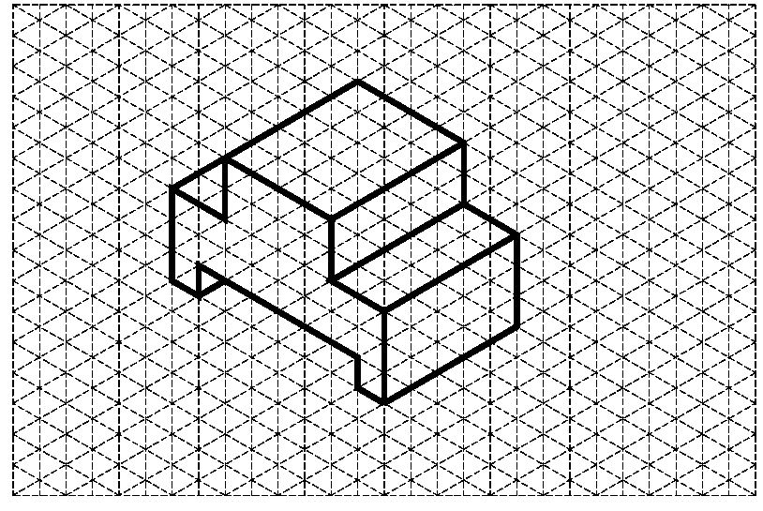
Figure 2: Isometric drawing of Brass Object One with 0.25” grid

Questions for Brass Object Two

- What are the physical properties presented in the CAD software? Include units.
  - Density _______________
  - Mass ___________________
  - Surface Area___________________
d. Volume ___________________

- Use the internet to research the accepted value for the density of brass in grams per cubic centimeter? Be sure to document your source.

- Convert the density of brass into pounds per cubic inch. Show your work including all conversion factors.

- What will be the total cost to ship 100 brass parts if the shipping rate is$4.25 per pound? Use the physical properties from the CAD analysis. SHOW WORK.

High Density Polyethylene Example 3 (see last page for guide to model this part)
You will begin by using Figure 2 isometric drawing to create a solid model. Use the part you created in Activity 5.5 part 2. Assign high density polyethylene as the object’s material and perform a physical property analysis. Record the CAD Physical property values to hand in with this packet. When you have completed the physical property analysis, answer the questions below.

Figure 3: Isometric drawing of High Density Polyethylene Object

- What are the physical properties presented in the CAD software? Include units.
A. Density ___________________
B. Mass ___________________
C. Surface Area ___________________
D. Volume ___________________

- What is the weight of the high density polyethylene part in kg? Show your work and include all conversion factors.

- How many parts can be made from 152 pounds of high density polyethylene? SHOW WORK.

Physical Property Analysis of Automoblox Vehicle
What if the material you plan to use is not listed in the software? There may be times that you will need to create a new material in the software and add the material specifications before you can perform the physical property analysis of a part. As in industry, there will be times that you need to “teach yourself” through use of the software tutorials and help menus. To accomplish this task, you will independently research and discover how to customize a 3D modeling software application to add a new material and its properties.

Use the 3D CAD software to perform a physical property analysis of the connector piece of your Automoblox vehicle. Create a new material in the software called "Automoblox Plastic". Use the density you found for the people in Activity 5.3 Determining Density and the other physical properties of ABS plastic.
Record the information below.

Print an isometric view of your connector piece and a copy of the CAD physical property values. Insert both into your engineering notebook.

- What are the physical properties presented in the CAD software? Include units.
  - Density (from Activity 5.3) _____1.0 g/cm³______________
  - Mass ____24g_______________
  - Surface Area ______11.977 in²_____________
  - Volume _______24 cm³____________

- If there is a 4% loss of material in the manufacturing process, how much material should be purchased to produce 10,000 connector pieces? SHOW WORK.

- If the cost of the plastic to manufacture the connector parts is $0.015 per cubic inch of material, what is the cost to manufacture 10,000 connector pieces? SHOW WORK.

Conclusion
- What do you need to know in order to perform a physical property analysis?

- Why is it important to understand the mathematics used in physical property analysis?

- Why is it important to perform a physical property analysis prior to producing a part?

- The clear enclosure piece and the wheels of the Automoblox are manufactured from polycarbonate. Do you think that the connector pieces are also manufactured from polycarbonate? Justify your answer.

